Connor McGrath

CSS 490B Spring 2017

Homework 2 Report

**Running the Program**

In order to run Connor_McGrath_490B_HW2.jar, ensure that the jar file and the /images/ folder are in the same directory. Then, double click the jar file. The GUI should launch immediately. The jar will then read the images from /images/* and create the necessary text files.

**Using the System**

To use the color code and intensity sorting mechanisms, first select a query image by left clicking the desired image icon. Then, select either the "Sort by Color Code" or "Sort by Intensity" button in order to sort the image set based on either the color code or intensity distances, respectively, to the query image.

To use the relevance feedback (color code + intensity) sorting mechanism, first click the check box labeled "Toggle Relevance". Then, select a query image by left clicking the desired image icon. Then, press the "Sort by Intensity + Color Code" button to perform the first search iteration, which uses the base feature weights. Then, select the "Relevant" check boxes next to the images that are relevant results. Then, press the "Sort by Intensity + Color Code" button to perform another search iteration. Repeat as many iterations of relevance feedback as needed by selecting relevant images and then pressing the "Sort by Intensity + Color Code" button.

Use the "Next Page" and "Previous Page" buttons at the bottom of the window to navigate between the five available image screens. Note that using one of the sorting methods will navigate to the first page to display the most pertinent results.

**Relevance Feedback Results**

Initial results (before RF with relevant images selected, precision = .45):

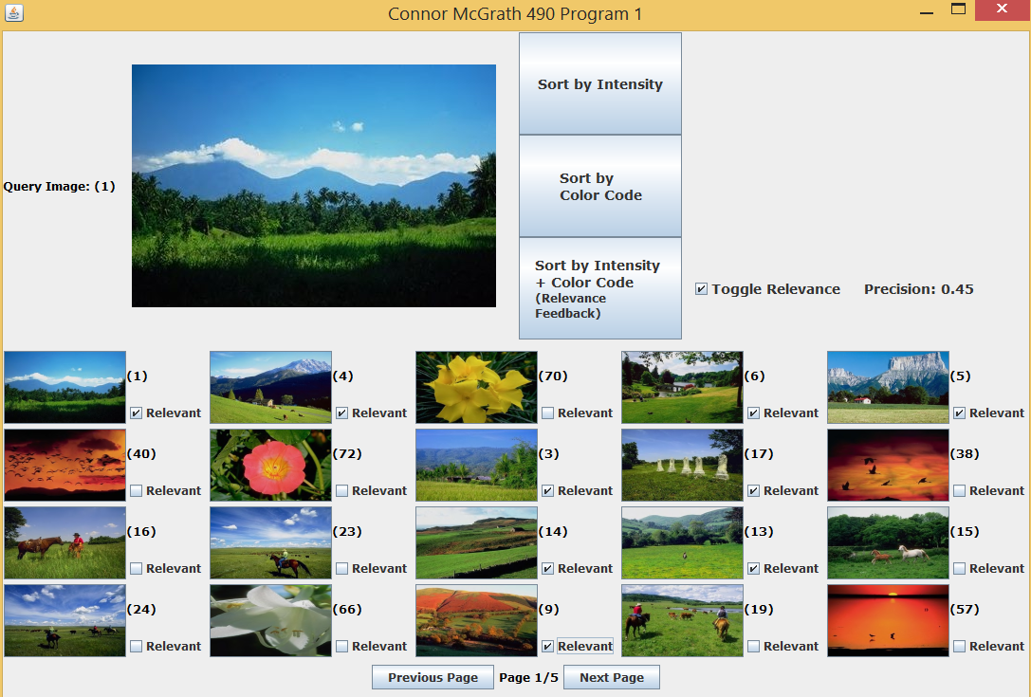

First iteration with new relevant images selected (precision = .65):

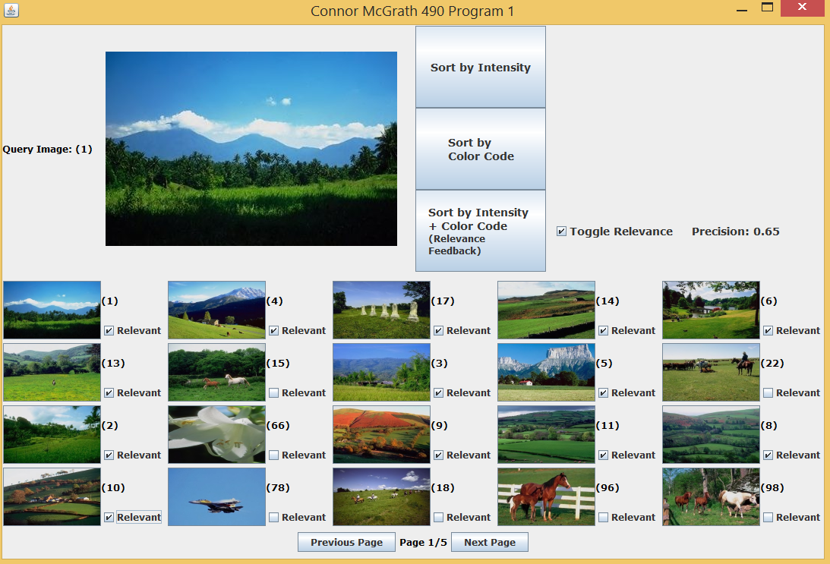

Second iteration result (precision = .7):

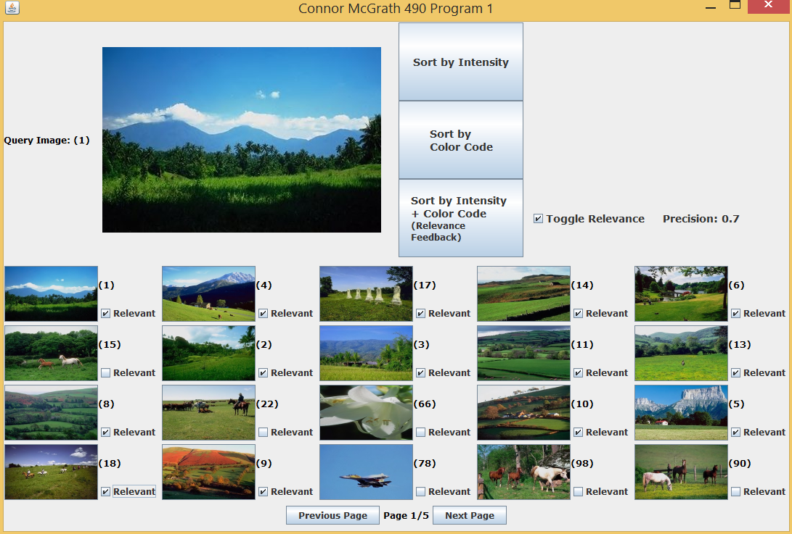

Third iteration results (precision = .7):

